CITIZEN’S CHARTER
2026

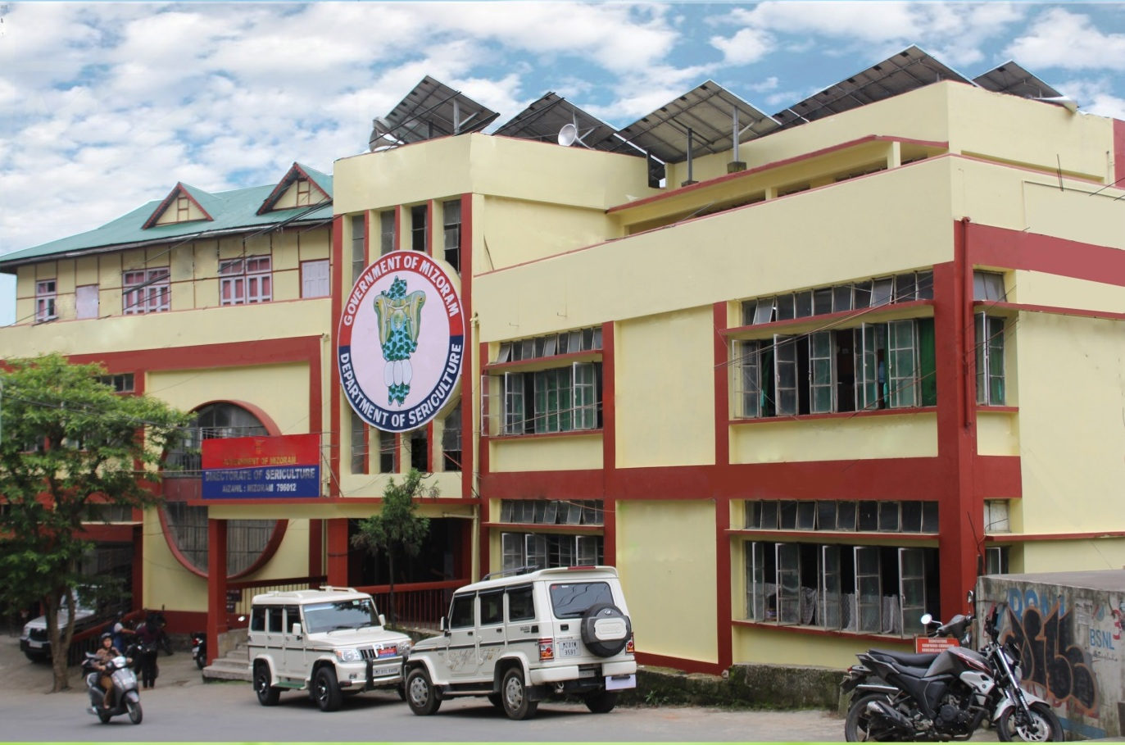

DEPARTMENT OF SERICULTURE
GOVERNMENT OF MIZORAM



DEPARTMENT OF SERICULTURE
GOVERNMENT OF MIZORAM



GOVERNMENT OF MIZORAM

CITIZEN’S CHARTER

FOR

DEPARTMENT OF SERICULTURE
FOR THE YEAR 2026

Address : Chaltlang, Aizawl
Website : sericulture.mizoram.gov.in
Date of Issue : 14.01.2026

CITIZEN’S CHARTER FOR DEPARTMENT/OFFICE OF
SERICULTURE DEPARTMENT (2026)

VISION AND MISSION

VISION: Uplift the poor by giving self employment opportunities & livelihood support through Sericulture and allied activities.

MISSION: 1) To uplift the rural economy in the State.
2) To generate direct and indirect gainful employment.
3) Creating sustainable livelihood for the rural poor.
4) To produce more cocoon and raw silk for the benefit of the farmer in particular and to increase State’s revenue in general.

CITIZEN’S CHARTER FOR DEPARTMENT/OFFICE OF
SERICULTURE DEPARTMENT, MIZORAM (2024)

MAIN SERVICES
Sl/No | Service delivered by the department/office to citizens or other departments/organisations including non-govermentalorganisations | Responsible official with designation | Email and Mobile (Phone No.) | Process for delivery of service within the department/office | Documents, if any, required for obtaining the service to be submitted by citizen/client | Fees, if any, for the service with amount
1. | a) Imparting training for In-Service for the development of Sericulture in Mizoram.  b)Training to the farmers on packages of practices on Mulberry, Eri and Muga. | Lalmuansangi  Principal, Sericulture Training Institute, Zemabawk. | lsangi73@gmail.com  9612125542 | As per need base | NIL | NIL
2. | Issue of Rearing equipment’s, disinfectants & Chemicals. | R.Lalzawmliana  Sericulture Extension Officer. | rlalzawmliana21@gmail.com  9436196197 | By submission of application and as per need base. | NIL | NIL
3. | Distribution/Supply of Dfl’s to the farmers | LalduhsakiRalte.  Sericulture Promotion Officer. | 16duhsaki@gmail.com  7086814154 | As per Crop schedule prepared by the Department | NIL | a) MullberryRs. 3/- per Dfl’s  b) EriRs. 3/- per Dfl’s  c) MugaRs. 5/- per Dfl’s  d) Oak tasarRs. 5/- per Dfl’s
4. | Purchase of seed cocoons from Farmers | LalduhsakiRalte.  Sericulture Promotion Officer. | 16duhsaki@gmail.com  7086814154 | As per Crop schedule prepared by the Department | Cocoon receipt | NIL
5. | Purchase of reeling Cocoons from farmers | All District Sericulture Officers. | dsoaizawlproject@gmail.com  sericulturellitps@gmail.com  champhaiseri@gmail.com  DSOseri2k@gmail.com  Mamitdso@gmail.com  dsoserchhip@gmail.com  dsosaiha@gmail.com  bawihpuiakb@gmail.com | As per Crop schedule prepared by the Department | Cocoon receipt | NIL
6. | Conduct survey on Crop yield, economics, Disease and Pest surveillance | All Technical staff. |  | As per need base | NIL | NIL
7. | Silk Processing (Post Cocoon Technology) to produce sufficient quality of raw silk, silk yarn and silk goods produced by the farmers. | F.Lalbiaknungi  Sericulture Inspector | Lalpuiif012@gmail.com  8974905122 | Through cocoon purchasing centres | NIL | NIL

CITIZEN’S CHARTER FOR DEPARTMENT/OFFICE OF
SERICULTURE DEPARTMENT (2024)

SERVICE DELIVERY STANDARD

Sl. No. | Services delivered by the department / office to citizens or other departments / organisations including non – governmental organisations | Stipulated time limit for delivery of service  (days/weeks/months) | Remarks, if any
1. | Issue of rearing equipment’s and chemicals to farmers | Within 1 week.
2. | Supply of Dfl’s to farmers | Within 1-5 days.
3. | Purchase of cocoons from farmers | Within 1-2 days at Cocoon Purchasing Centers. | The cocoons produces by the farmers all over Mizoram are collected and deposited at Reeling & Spinning Centre, Zemabawk, whereby processing and reeled producing raw silk and yarn are done. The products are then sold to various consumers all over India.

CITIZEN’S CHARTER FOR DEPARTMENT/OFFICE OF
SERICULTURE DEPARTMENT (2024)

GRIEVANCE REDRESS MECHANISM

The Directorate of Sericulture does not have any separate Grievance Redressal cell at present. As such every citizen is free to meet the following Officers for redressal of their Grievance at the Government level.

Sl. No. | Name of the responsible officer to handle public grievance in the Department/Office | Contact number | Email | Time limit for redress of grievances
1. | Lalrinawma  Director of Sericulture, Mizoram | 0389-2341398 (O)  9862342050 (M) | lalrinawmahmar10@gmail.com | As per Guidelines
2. | B. Lalchhuana  Joint Director of Sericulture | 0389-2341398(O)  8014366473 | Bchhuana4@gmail.com | As per Guidelines
3. | R.Lalthanfeli  Superintendent  Department of Sericulture, Mizoram | 9436154667 | mathaniralte13@gmail.com | As per Guidelines

CITIZEN’S CHARTER FOR DEPARTMENT/OFFICE OF
SERICULTURE DEPARTMENT (2024)

LIST OF STAKEHOLDERS/CLIENTS

Sl. No. | Stakeholders/Clients
1. | Farmers (Sericulture) Farmers who own a piece of land, who have cultivated Mulberry, Eri, Muga and Oak Tasar to rear silkworm to result in cocoon production.
2. | Seed growers : Persons who rear silkworm for production of seed cocoons.
3. | Reelers/weavers and other stake holders: Convert perishable commodity – the cocoons to stable commodity – the raw silk through mechanized processes and interventions, varying upon investment and quality of raw material used.
4. | Chawkirearers : Persons who have created facility to rear/tend the newly hatched silkworm between 0-10 days (approx.)

CITIZEN’S CHARTER FOR DEPARTMENT/OFFICE OF
SERICULTURE DEPARTMENT (2024)

EXPECTATION OF THE DEPARTMENT/OFFICE FROM CITIZENS/SERVICE RECIPIENTS
Sl. No. | Expectations of the department/office from citizens/service
1. | Productions of quality cocoons from farmers.
2. | Utilization of material supplies as per provision
3. | Result of good feedback information.

